**Name: Tanvir Ahmed**

**Date: June 15 2025**

**Phase 3: Identify Vulnerabilities**

**Intro:**

After completing reconnaissance in phase 1, and port scanning in phase 2, it's time to identify the vulnerabilities in the target system, Artemis. Vulnerability identification can be done with various tools such as OpenVAS, Nessus, Metasploit, Zenmap, and Wapiti.

**Procedure:**

**OpenVas**

It is a full featured vulnerability scanner integrated in Kali Linux, maintained by Greenbone Networks. Capable of port scanning, banner grabbing, TCP/UD service detection, and OS fingerprinting.

**Pros:**

It is a free making and open source tool, an ideal choice to use for vulnerability scanning. The website has many customizable scans on severity, family and target range, with a GUI. Also provides detailed reports with recommendations to fix the vulnerabilities.

**Walkthrough:**

The service needs to be started in the terminal then with the right server it would be directed to access via web application. After logging, simply inputting the target ip address can start the scanning which can be customized for periodic scanning with host discovery and different tasks. The report at the end will showcase the area of vulnerability such as OS fingerprinting, CPE inventory, services and others.

**Cons:**

The scanning is very time consuming and can take several minutes for 1 target scan to complete. The configuration is somewhat complex and not for beginners. 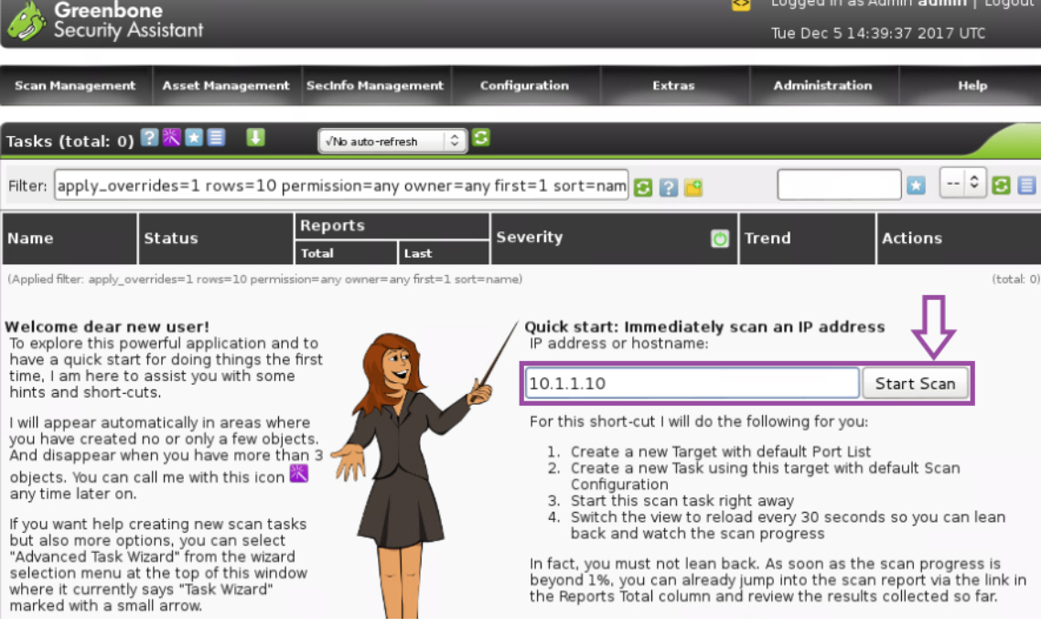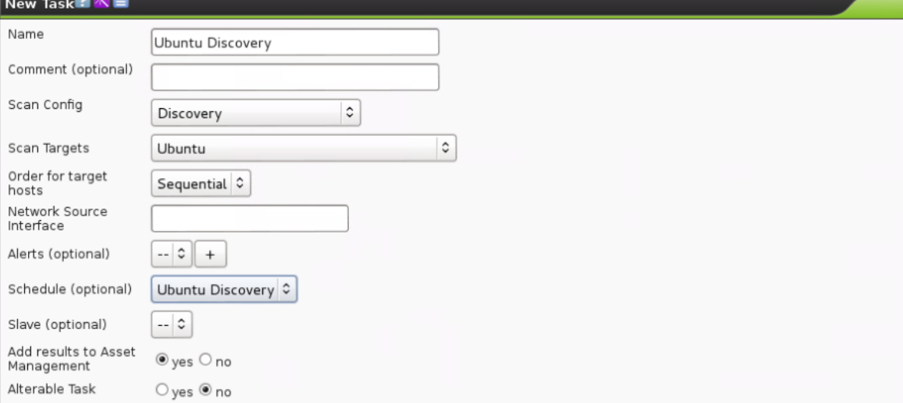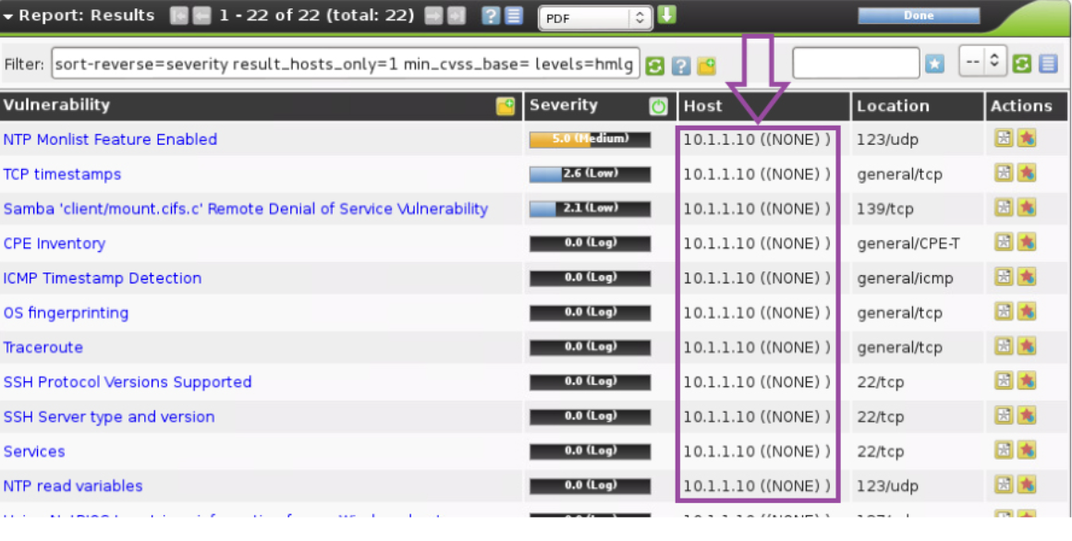

**Tenable Nessus**

A powerful, accurate, and widely commercial vulnerability scanner ideal for scanning both internal and external environments. For our target Artemis, this tool is a good fit to assess internal and external assessments. It also does port scanning, service version, sql injections detection, and open redirects.

**Pros:**

It is a tool that has very accurate detection compared to other tools and has daily updates keeping scanned databases up to date. It comes with a user friendly environment, and can detect outdated software, weak credentials, and misconfiguration and CVEs. Generates well organized and customizable reports.

**Walkthrough:**

For the web application, a registered user can put their target Ip address and it would do a basic network scan. After the scan is complete, it would showcase individual vulnerability present in the network. In each vulnerability it would present the severity, with publish and modification date along with CVE reference link and port it exists. 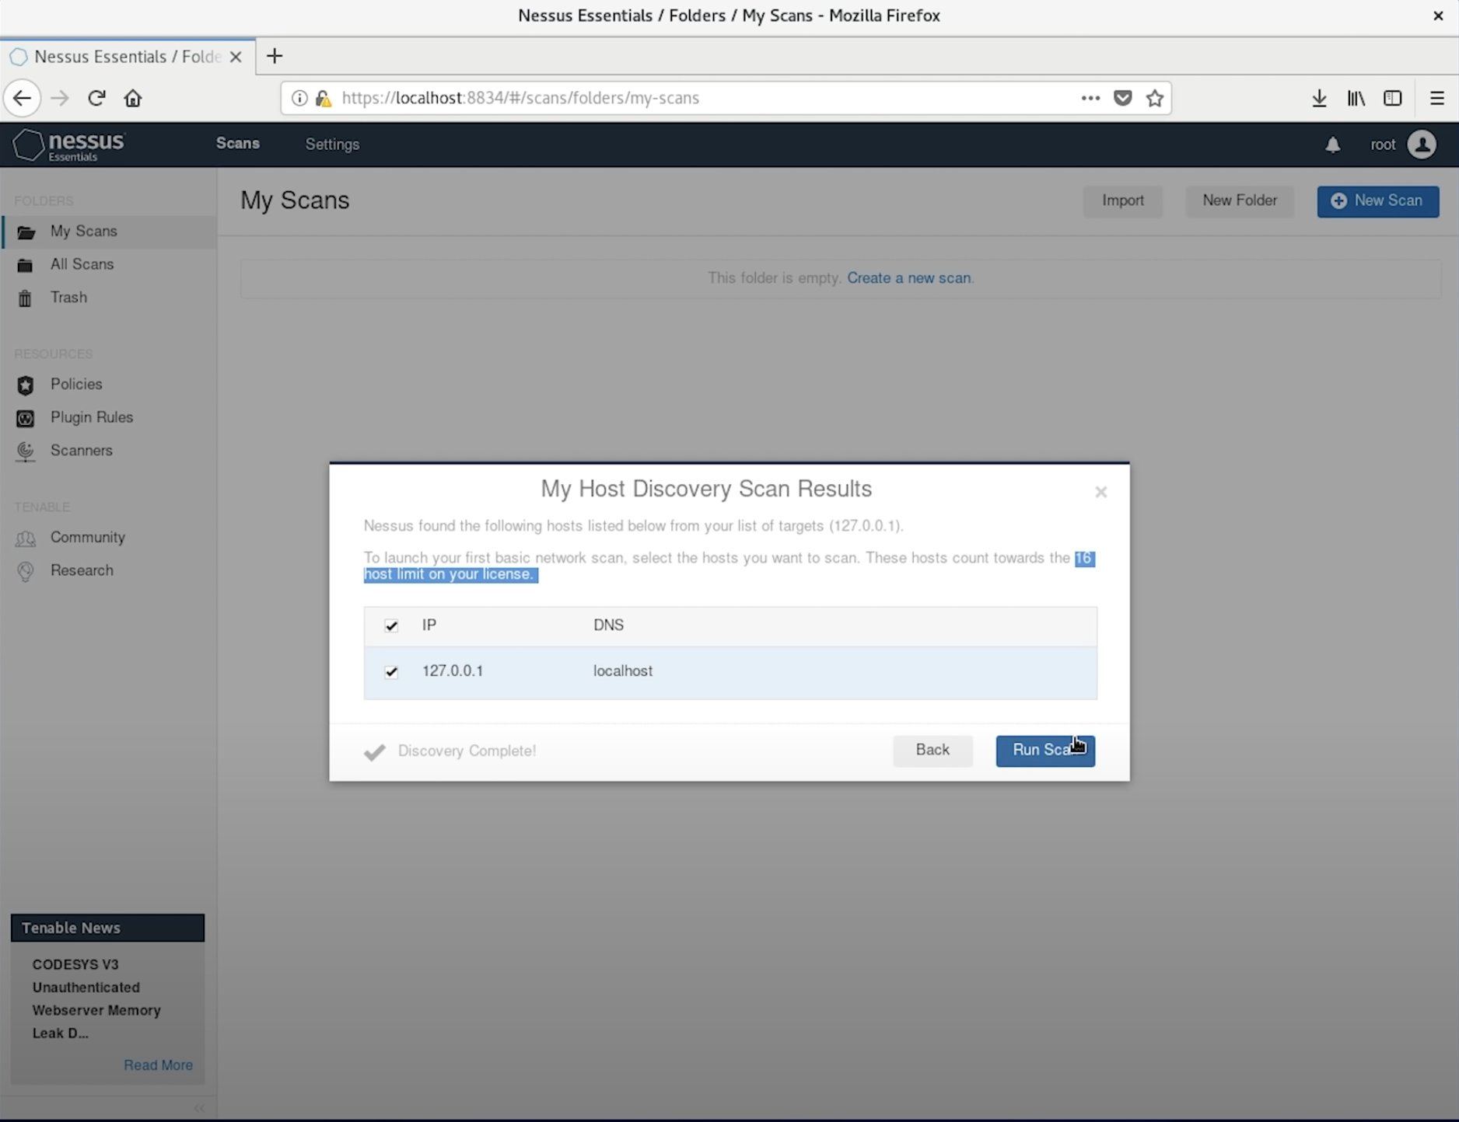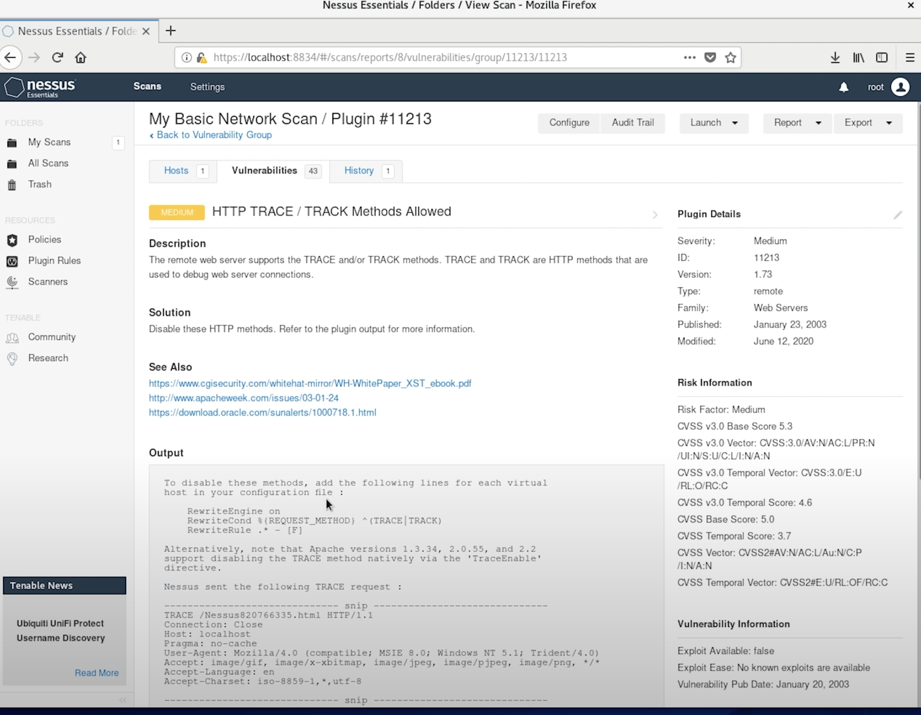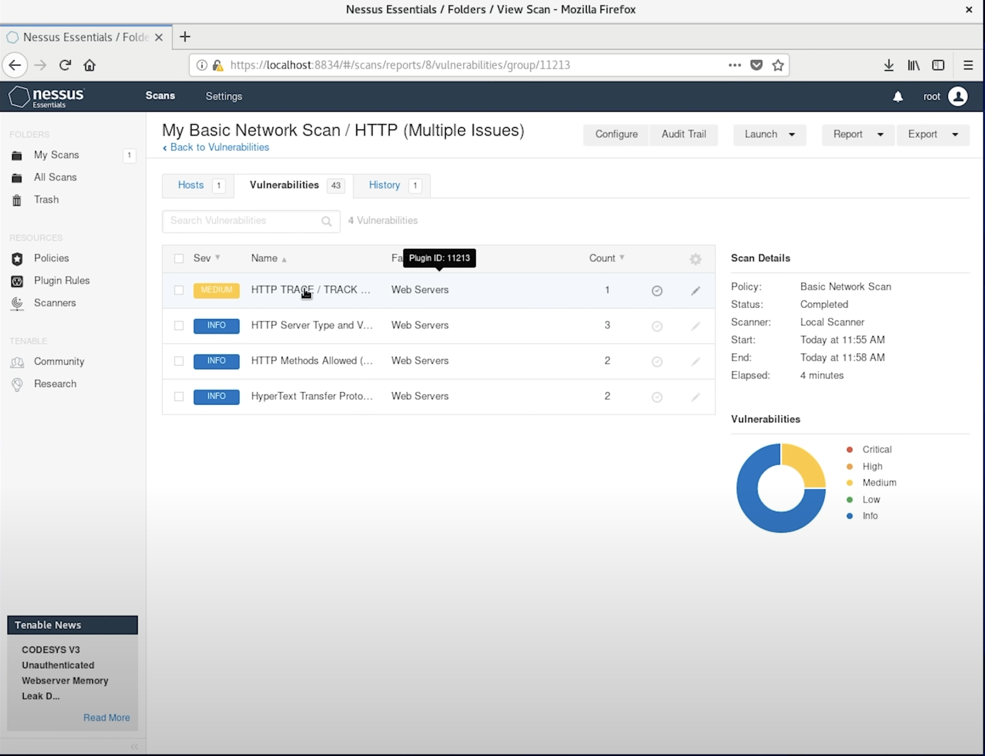

**Cons:**

The basic scan is free, but for the full version a subscription is required. Nessus only has a vulnerability management system and scanning tool, it is not for exploitation. Even Nessus scanning can be blocked by IDS and firewalls.

**Zenmap**

We have already used nmap for port scanning and found it very useful to identify the target. With Zenmap and its GUI the nmap is further enhanced in a user friend interface, giving more freedom and customization on port scanning and vulnerability checks.

**Pros:**

It is GUI based with visual maps and topology, it gives a clear use of application with visual reports on topology maps supporting nmap scripts.

**Walkthrough:**

With commands like “nmap -sV [Artemis.com](http://artemis.com)” in Zenmap, it would reveal the service version that can be checked manually for known CVEs. Inputting the target ip with nmap command in Zenmap, it can detect the open ports that may potentially be active and contain vulnerability. This tool would help to detect vulnerability by checking those open and active ports.

**Cons:**

Very basic for vulnerability scanning and doesn’t automatically detect known CVEs and doesn’t update for new databases of vulnerability. Tends to be slower for large networks.

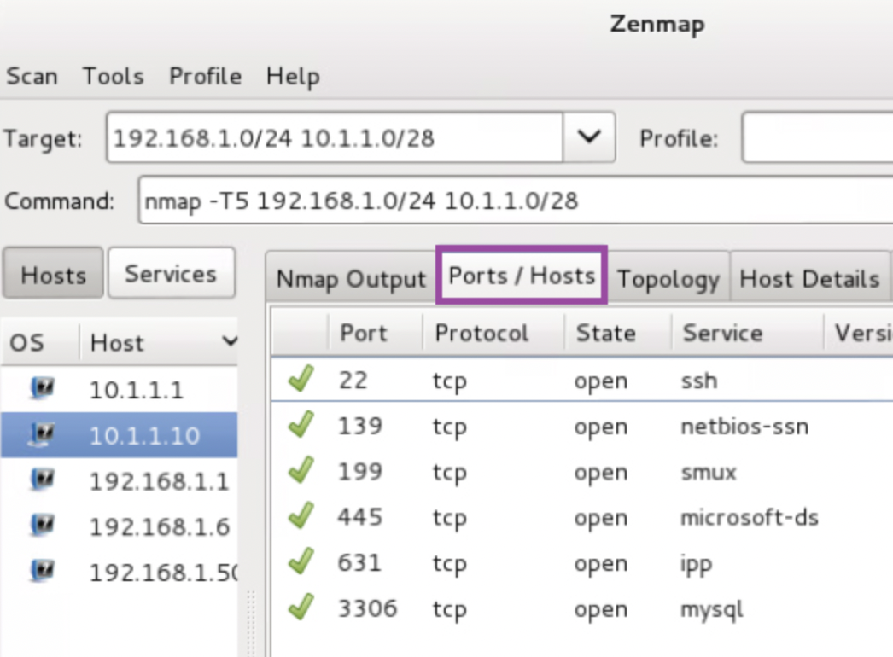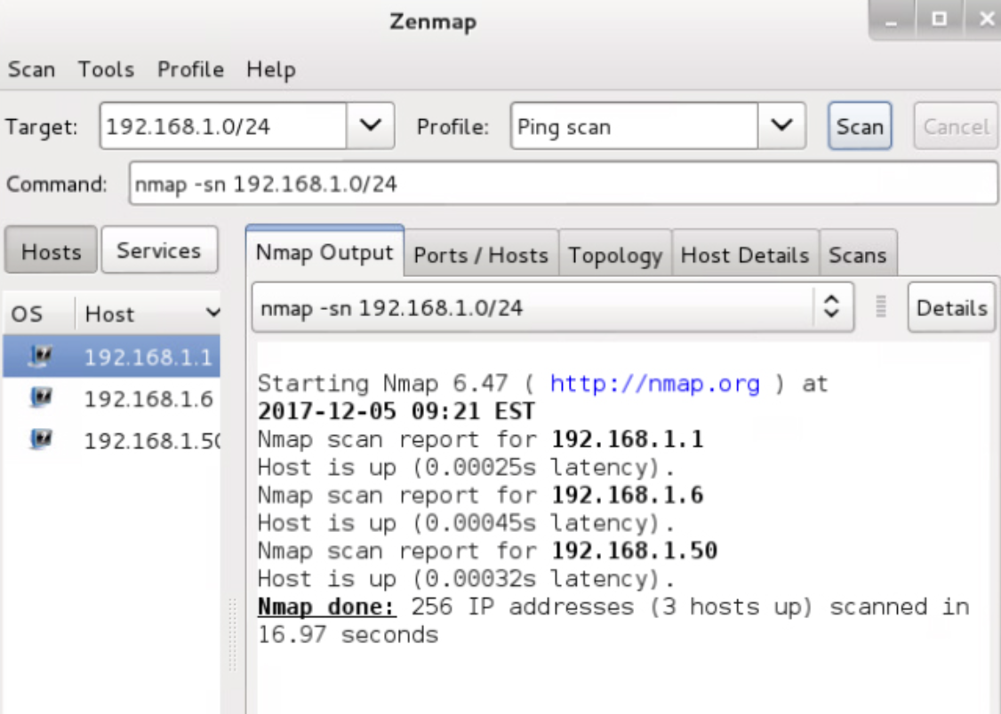

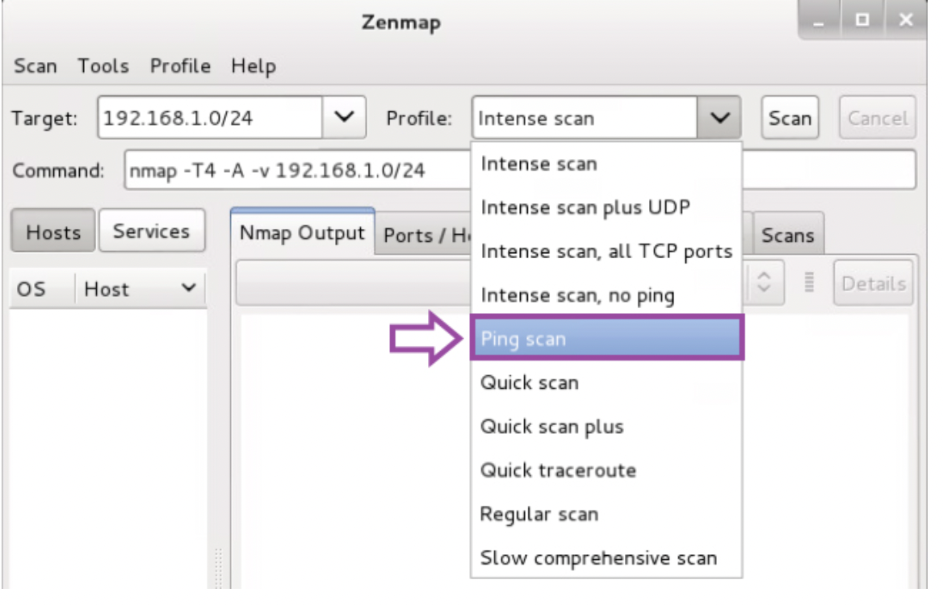

**Metasploit**

It is a widely used tool and penetration testing framework for scanning and exploiting vulnerabilities.

**Pros:**

It gives the option to be modular, performing various tasks and giving the flexibility of stealthy shells for Meterpreter. Notjust scanning it can even be used for exploitation. Integration with armitage provides GUI interfaces that support playloads, and auxiliary modules.

**Walkthrough:**

Inside Armitage we can use the metasploit scanning option to input the host address which is Artemis and find areas in which there exist vulnerabilities and can be attacked. Command like “db_namp” can be used to find vulnerabilities.

**Cons:**

It doesn’t automatically showcase the CVEs after scanning and can be complex with the commands if there is prior experience. Can easily be detected by IDS/IPS if not used stealthily.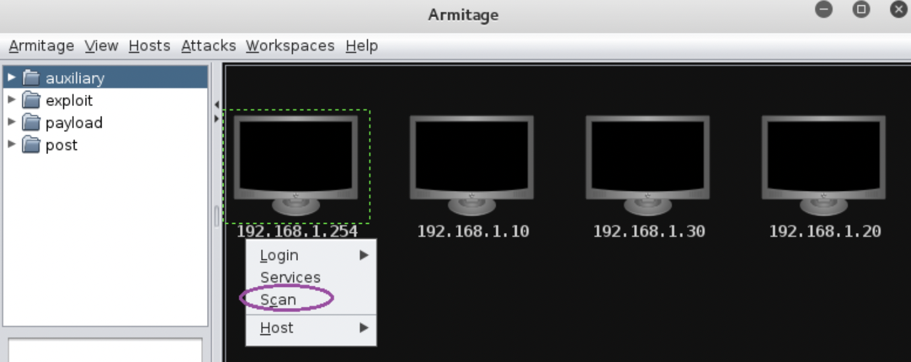

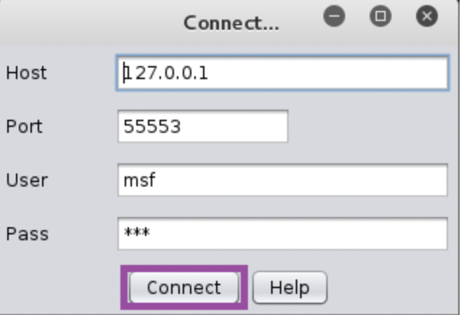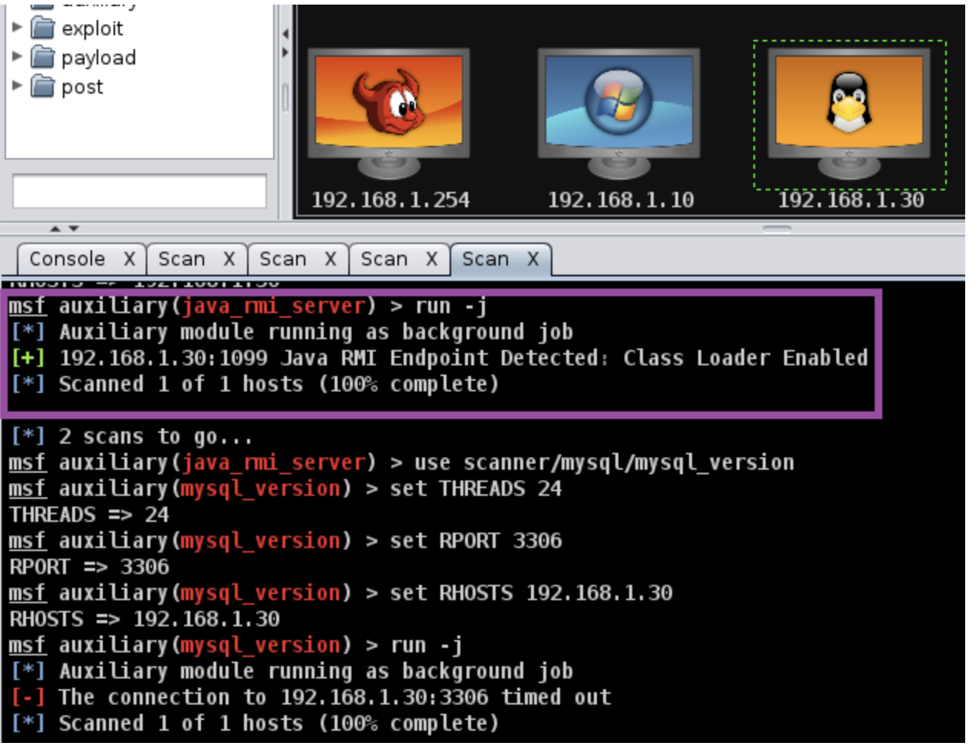

**Wapiti**

It is another CLI_based web application tool known for vulnerability scanners. It scans live web applications for CVEs that perform black box testing.

**Pros:**

It checks a variety of vulnerabilities including SQl injections, XSS, command line injection, file disclosure, and open redirects. It even checks for http header manipulation. It is very easy to use and fast because of no GUI. Generates structured vulnerability reports.

**Walkthrough:**

Command like “wapiti -u [Artemis.com](http://artemis.com)” will scan for basic vulnerabilities. It will automatically check for CVEs and generate a report and number of each CVEs found.

**Con:**

Limited to unauthenticated areas only and requires session injection for authenticated areas. Can be detected by WAFS/IDS.

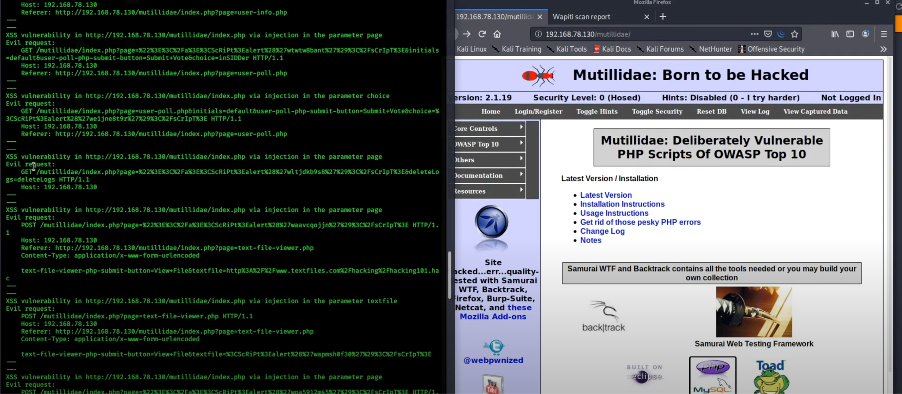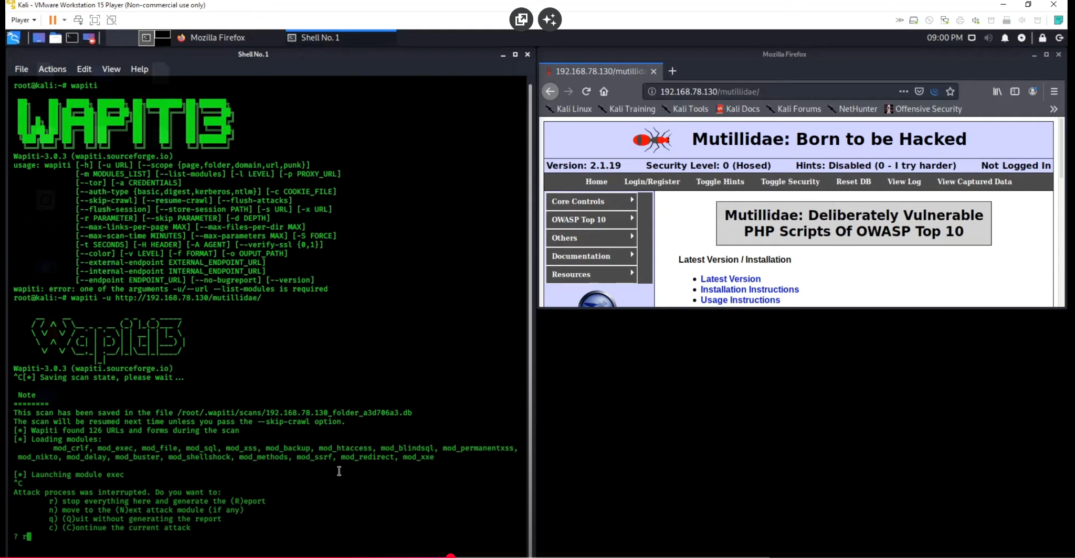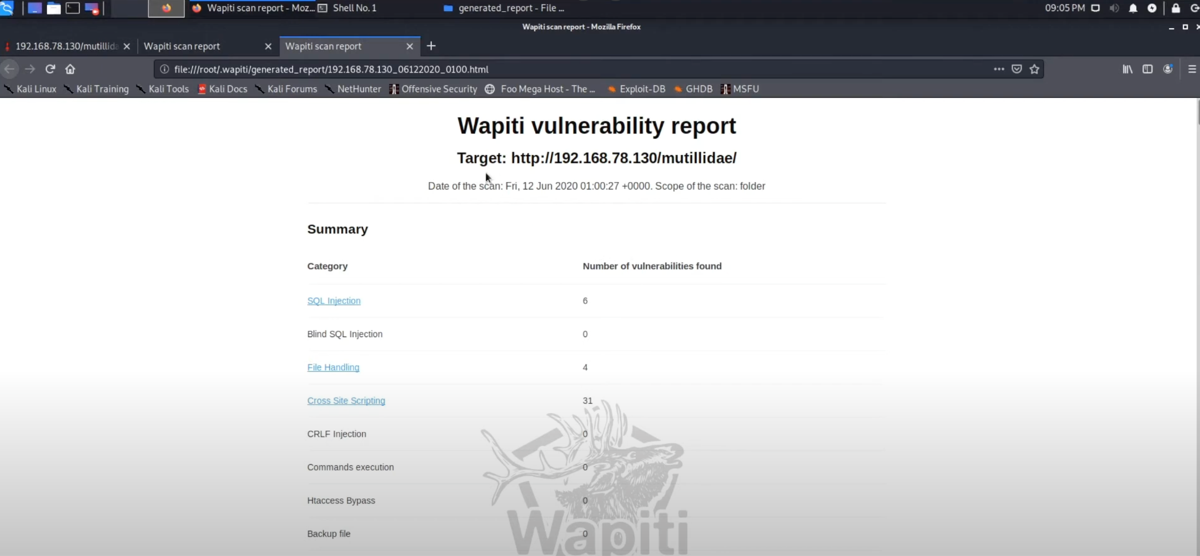

**Burp Site:**

Another powerful web vulnerability scanner for testing web application security is Burp Site. It allows for manual testing of vulnerabilities in a dynamic web application by intercepting, modifying and repeating requests between client and server.

**Pros:**

It intercepts traffic like HTTPs for analysis. Can detect SQL injections, XSS, XSRF, open directives and more. Very useful for authenticated scans and reusing session tokens. Has a built in repeater and scanner that supports advanced enumeration.

**Walkthrough:**

The browser of Burp Site needs to be configured first and when the target Artemis is visited through the browser it will intercept and inspect the request. The passing traffic would scan for automatic vulnerability.

**Cons:**

The free version lacks the automated scan, only open to manual testing. The tool requires knowledge on web protocols. Also, not ideal for full network scanning.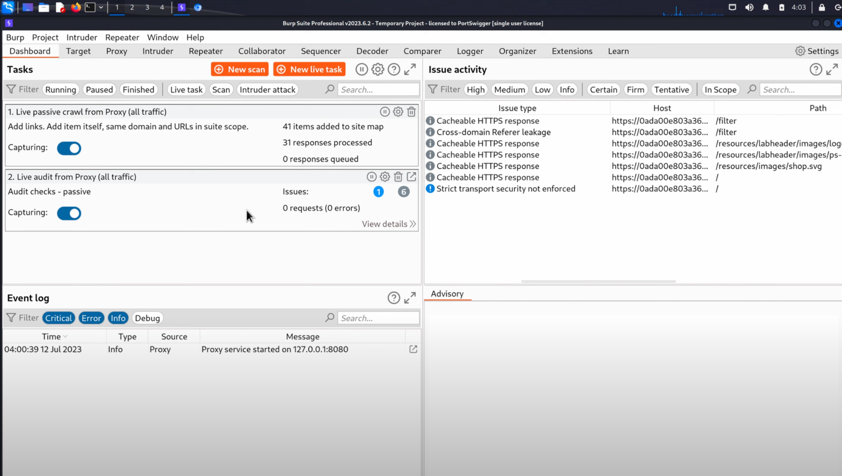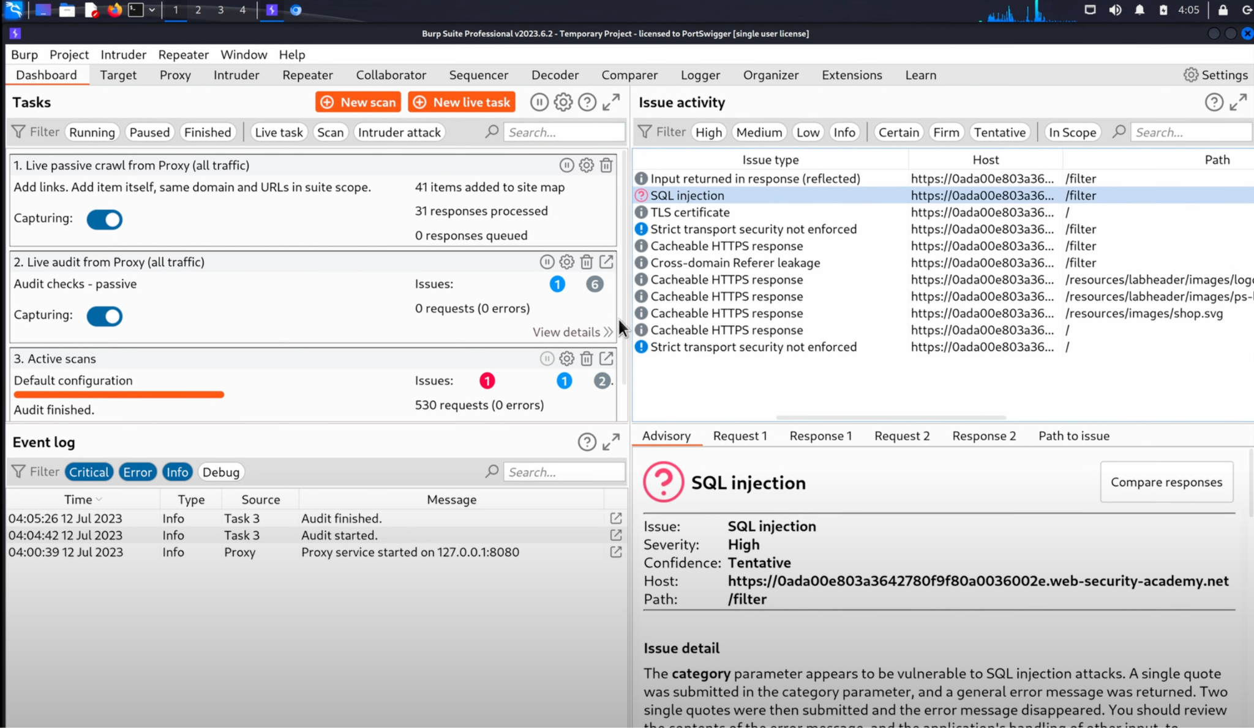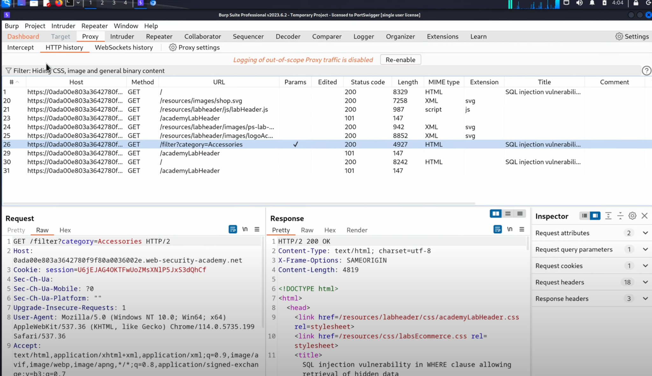

**Conclusion:**

In order to identify vulnerability of web applications for our target Artemis ,many different tools can be used including OpenVAS, Nessus, Metasploit, Zenmap, Wapiti and Burp Site. Each tool has distinct pros and cons, but they all can identify vulnerabilities, allowing to monitor for weakness for many different areas and generate reports to exploit or harden the system.